**Department of Computer Science and Engineering**



Report on Mini Project

Online Quiz Website

#### Course Code : 20CSE41 Course Name : Web Programming

##### Semester: V SEM Section: A & B

**Submitted To: Shruthi Mam**

## Faculty Name

## Designation

## Department of Computer Science and Engineering

**Submitted By:**

Amrutha Joshi

K N Anvitha

Jayashree

**Date of submission: 15-12-2022**

#### 

#### Signature of Course Instructor

# ABSTRACT

The purpose of Online Quiz System is to automate the existing manual system by the help of computerized equipment’s and full fledged computer software. Here we have developed a project on quiz website on Hindi/English movies and series. By means of this project, we aim to offer a wide range of fun quizzes based on Hollywood, Bollywood series and movies. 100s+ of fun quizzes on your favorite characters and shows which are absolute free. From cool personality quizzes to fun trivia we've got all the quizzes you love to binge.

A user can play/attempt all of the quiz. There will be a limited number of questions and and for each correct answer user will get a credit score. User can see answers as well as give a review related to it. There are many quiz application available currently on internet. But there are few which provide better understanding between users and application, like providing proper answers, rank list, uploading user questions as well as answer to it.

The project is designed using HTML, CSS, JavaScript and Bootstrap for the frontend development. MySQL server for database connectivity and PHP as a part of backend development.

# TABLE OF CONTENTS

Title Page i

Abstract ii

Table of Contents iii

Introduction

Problem Statement

Objectives

Hardware/Software Requirement

Methodology

Implementation Details

Results

Conclusion and Future Scope

References

# INTRODUCTION

# The "Online Quiz System" has been developed to override the problems prevailing in the practicing manual system. This software is supported to eliminate and in some cases reduce the hardships faced by this existing system. Moreover this system is designed for the particular need of the company to carry out operations in a smooth and effective manner.

# Our aim is to develop a application for the users in which a user can attempt any number of quiz related to his/her choice. Firstly, we have to make interfaces for Home Page, Registration, Login Page, Questions Attempting forum, Result Page, & Profile of user. These all pages have connectivity with the server and database. So, that it can work properly. Currently, there are websites which only provide limited number of quizzes related to different domain. Many websites do not have a single platform for quizzes related to both series and movies. We have to develop a application which can resolve all of the above problems. By this application the user will come to know about his/her level and learn additional knowledge. Also by this application user can expand his/her knowledge about their favorite movies and series.

# PROBLEM STATEMENT

# QUIZ SYSTEM is a software developed to conduct an Online Quiz based on time constraints. Quiz System is accessed by entering the username and e-mail id which is added to the database. Before start of the Quiz, the rules and regulations are displayed that includes description of time limit, number of questions to be answered and scoring methods. Quiz is started by displaying ten questions with four options each based on category chosen ie. English movies, English series, Hindi movies or Hindi series. If the answer is correct, score is incremented by one and no negative marks for wrong answers. Final score will be displayed and updated in the database with username. Users can also view their rank in the rank list.

# Features –

# User accounts to control the access and maintain security

# Better storage capacity

# Accuracy in work

# Easy and fast retrieval of information

# Decrease the load of the person involving in existing manual system

# Access of any information individually

# Work becomes very speedy

# Robust database back-end

# OBJECTIVES

The main objective of the Project on Online Quiz System is to facilitate a user friendly environment for all users and reduces the manual effort. It manages all the information about related to this website. The project is totally built at administrative end and thus only the administrator is guaranteed the access. The purpose of the project is to build an application program to reduce the manual work. It tracks all the details about the Topic, users , Quiz.

# It tracks all the information of question, result and user

# Manage the information of question

# Manage the information of user

# Editing, adding and update of records is improved which results in proper result management

# Movie quiz system also manages the result details and user details

# Integration of all records of quiz

# HARDWARE / SOFTWARE Requirements

# HARDWARE REQUIREMENTS -

# Processor :AMD PRO A4-4350V R4,5COMPUTE CORES 2C+3G 2.50GHz

# RAM: 4GB

# SOFTWARE REQUIREMENTS -

# Operating System: Windows

# Backend: MySQL, PHP

# Frontend: HTML ,CSS, Bootstrap, JavaScript

# Browser: Google Chrome

# Editor: Virtual Studio Code

# METHODOLOGY

# DFD -

# USE CASE DIAGRAM –

# ENTITY – RELATIONSHIP DIAGRAM –

**Home page** :

The user can access various pages including quizzes, about us, login and rank list.

**Login module**:

User can login using their registered email and password. A new user can sign-up by entering their name, email and password.

**Profile page:**

Provides information about users name, email and current score.

**Quiz module**:

Users can attempt any number of quizzes from Hollywood/Bollywood movies and series each category consisting of 3 sets.

**About us page**:

This page gives insight into our website and the people behind it. Provides an essential source of information for all who want to know more about our quiz website. This page also provides its users to give review on our website.

**Rank list page**:

Displays the score and lets users to know their rank.

# IMPLEMENTATION

# Frontend :

# The view of the language is constructed using HTML(Hyper Text Markup Language) ,CSS(Cascading Style Sheets) and JavaScript. These are required for responsive web development. It does not any codes or database to the customers. It is used for interaction and for data input purposes only. The frontend was coded and created using Visual Studio Code as it enables error detection and debugging. It has built-in libraries and functions which are readily available.

# Backend :

# For backend , a programming language called PHP(Hypertext Preprocessor) is used to connect the database. The database is created using MySQL to store, insert and delete data. The framework used for backend codes is Visual Studio Code. The PHP is connected to the database using the server provided by Apache. It is built using XAMPP, a database provider for PHP. PHP, MySQL, Apache work I synchronization to enable smooth functioning of the backend.

**6**

**RESULTS AND DISCUSSIONS**

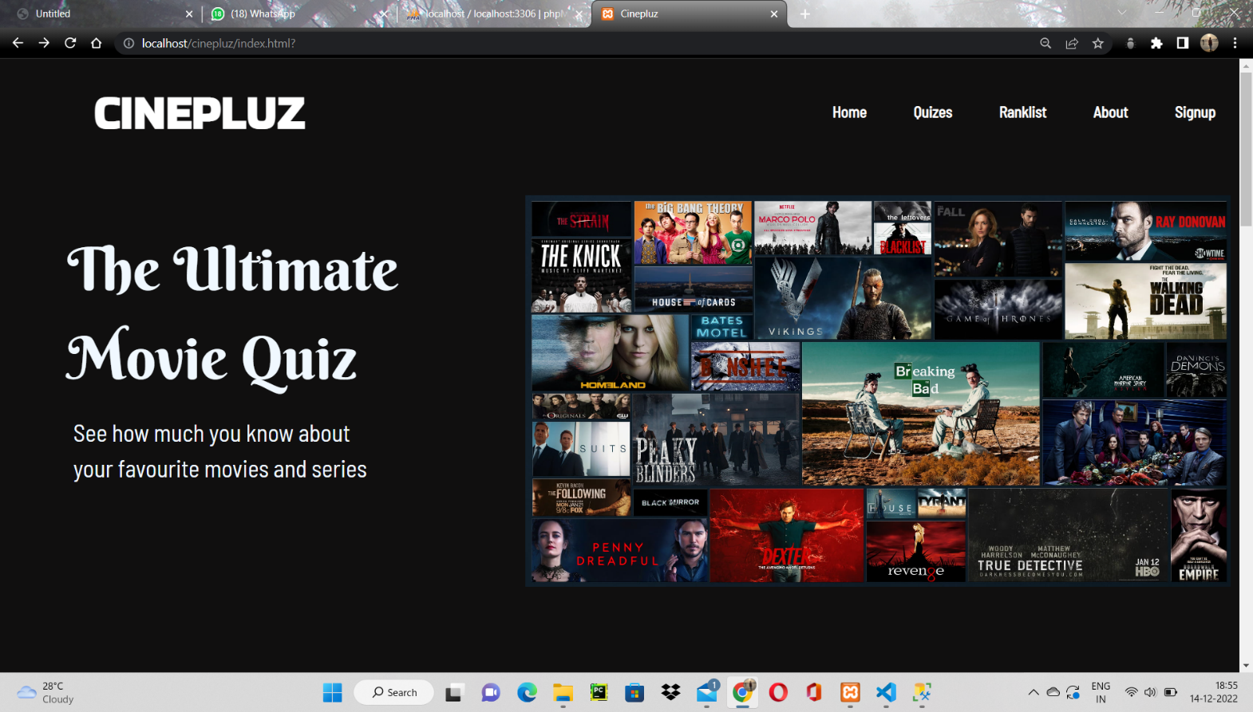

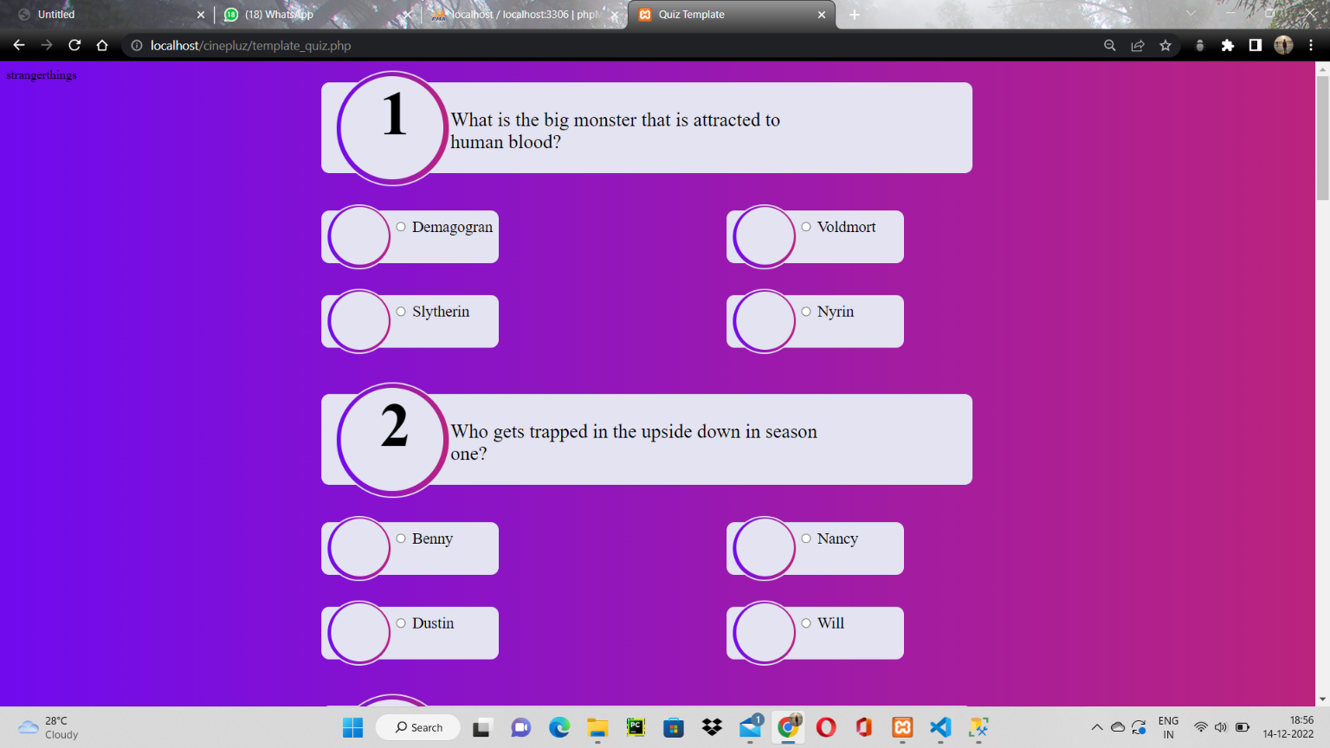

# CONCLUSION AND FUTURE SCOPE

Quiz application provides facility to attempt quiz anywhere and anytime. It save time since user

does need to wait for result. So user cannot wait for the result. All user get extra knowledge and skills. Administrator has a privilege to put as much as question in given Quiz in application. User can register, log-in to attempt Quiz. If user forget their password then he/ she can reset password with the help of Forgot Password option. There is instruction page for students get information about quiz like number of question, given time etc. After that user get the result of quiz. Also admin is responsible to add, delete and update question in the system. Also we can view result of all user in the rank list.

It has been a great pleasure for us to work on this exciting and challenging project. This

project proved good for us as it provided practical knowledge of programming in JAVA and

MYSQL server and also about all handling procedure related with Quiz System. It also provides knowledge about the latest technology used in developing application and server technology the will be great demand in future. This will provide better opportunities and guidance in future in developing projects independently. This Quiz Application can be efficiently used by any users. During the course of this assignment we have gone through many obstacle which made us to research and also increase knowledge.

At last it can be concluded that the “Quiz Application” was the real learning experience.

The project has been made as per as the mentioned specification.

# REFERENCES

1. www.w3school.com

2. [www.youtube.com](http://www.youtube.com)

3. [www.google.com](http://www.google.com)

4. [www.getbootstrap.com](http://www.getbootstrap.com)